Arrow function

They don’t have own this keyword. They inherit that from the parent scope whenever you call this keyword.

Return statement

Don’t use return statement.

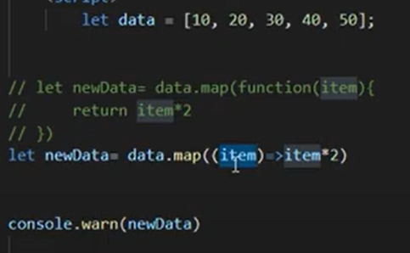

This keyword

Since it has no this keyword, it should be part of parent function. We cannot use Arrow function at object. When it is only a object it’s parent is window object.It always indicates parent function in this case it is window object. We can use arrow function inside object if there is normal function.

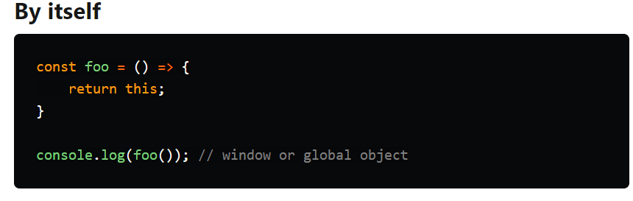

Here works arrow function. Arrow function covers with outer side normal function. So that order function belongs main, side and dessert. And arrow function references order function. But if there is no order function it would say undefined.

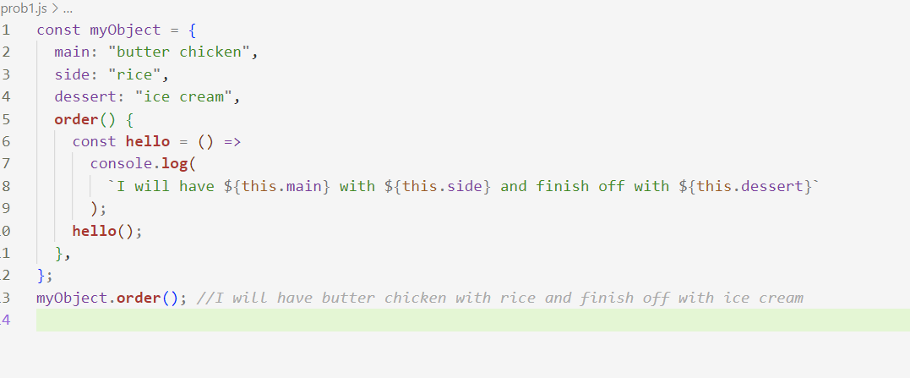

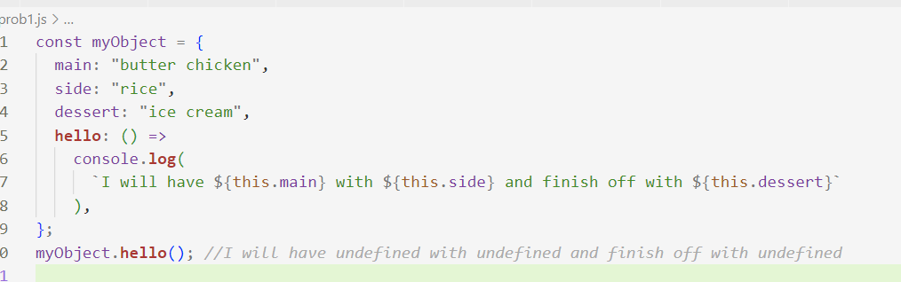

How to works class component arrow function and normal function

